Smart Farmer - IOT Enabled Smart Farming Application

**Sprint – 4 :**

|  |  |
| --- | --- |
| **Team ID** | PNT2022TMID50617 |
| **Team Leader** | MARI MUTHU.K |
| **Team Members** | ESAKKI MUTHU.P  SURESH.G  KANNAN.T  THEN RAJAN |

**User Interface of App**

* Dashboard:

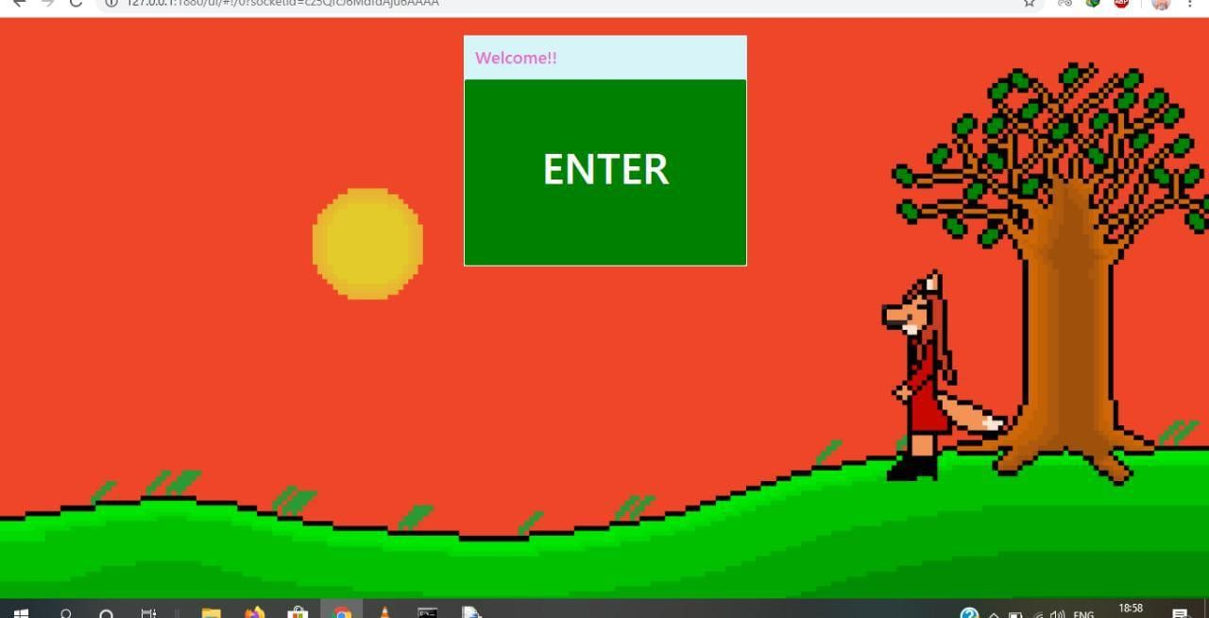

* Screen-1:

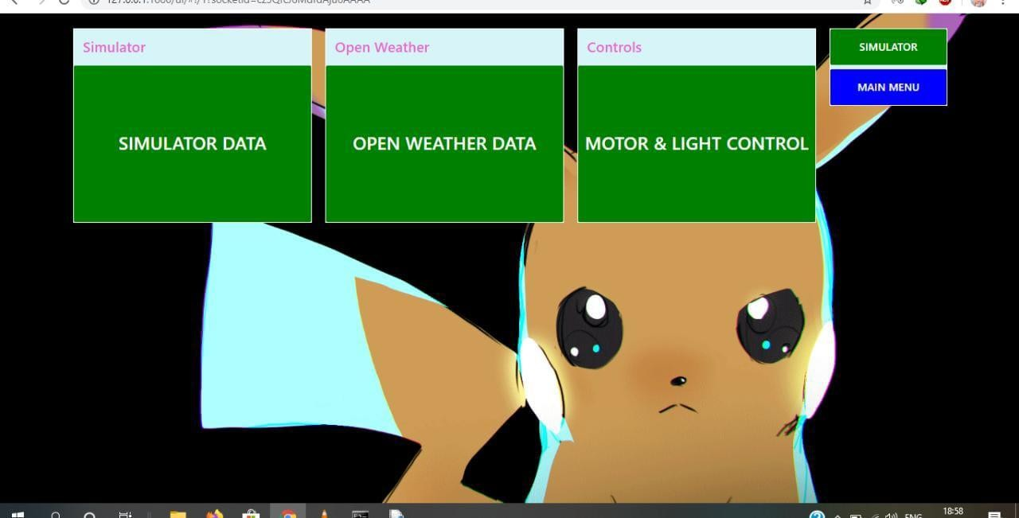

* Simulator data:

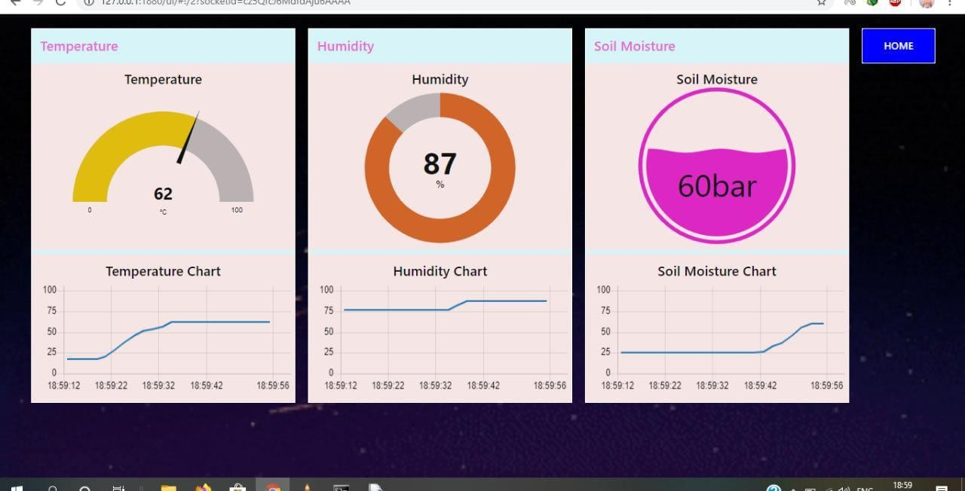

* Open Weather data:

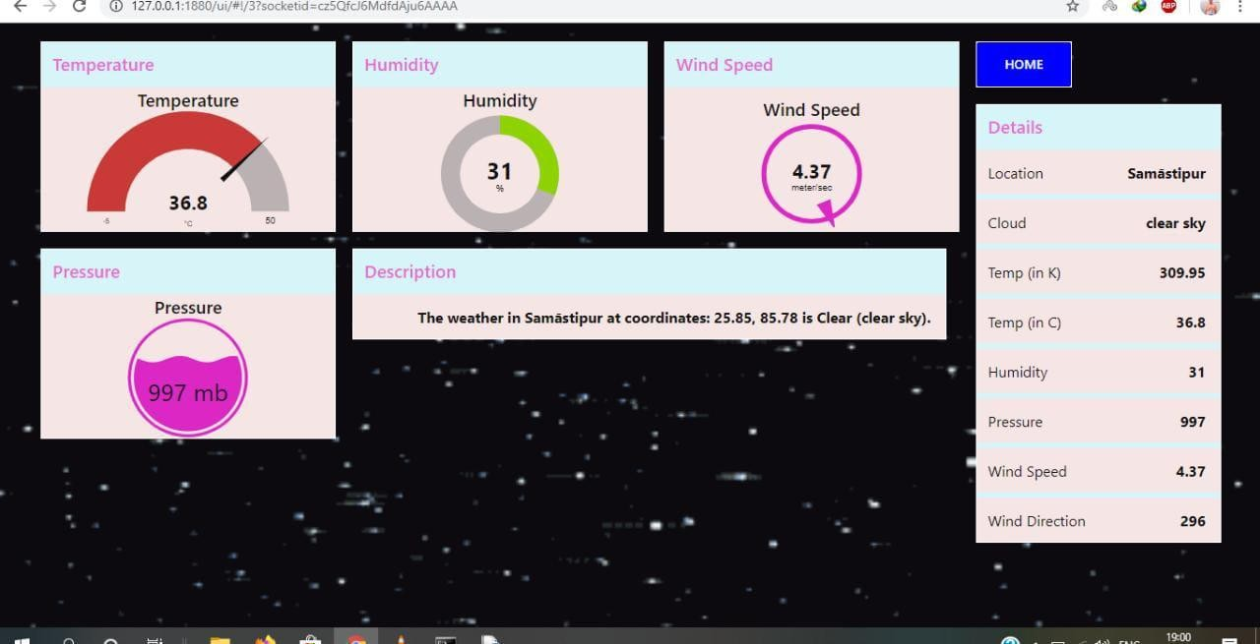

* Motor and Light control:

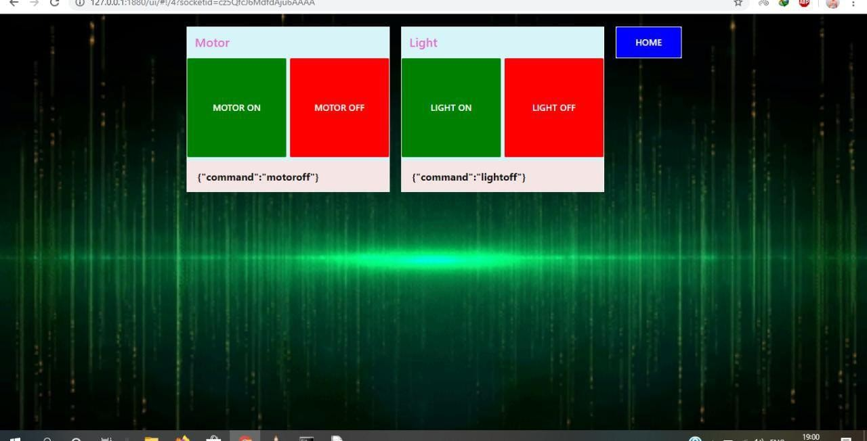

* Output:

